Министерство образования Республики Беларусь

Учреждение образования

«Брестский государственный технический университет»

Кафедра ИИТ

Лабораторная работа №5

По дисциплине: «Нелинейные ИНС в задачах распознавания образов»

Выполнил:

Студент 2-го курса

Группы ПО-7

Гункевич И.А.

Проверил:

Крощенко А.А.

Брест 2021

**Цель работы:** Изучить обучение и функционирование нелинейной ИНС при решении задач распознавания образов.

|  |  |  |  |  |  |  |  |  |  |  |  |  |  |  |  |  |  |  |  |  |
| --- | --- | --- | --- | --- | --- | --- | --- | --- | --- | --- | --- | --- | --- | --- | --- | --- | --- | --- | --- | --- |
| 3 | 1 | 1 | 1 | 1 | 0 | 0 | 0 | 0 | 1 | 1 | 1 | 1 | 0 | 0 | 0 | 0 | 1 | 1 | 1 | 1 |
| 2 | 0 | 0 | 0 | 0 | 1 | 1 | 1 | 1 | 0 | 0 | 0 | 0 | 1 | 1 | 1 | 1 | 0 | 0 | 0 | 0 |
| 8 | 1 | 1 | 1 | 0 | 0 | 0 | 1 | 1 | 1 | 0 | 0 | 0 | 1 | 1 | 1 | 0 | 0 | 0 | 1 | 1 |

**Задание**

**Код программы:**

#include <iostream>  
#include <math.h>  
#define NUMBER_IN 10  
#define NUMBER_HID 4  
#define NUMBER_OUT 1  
#define e 2.71828  
using namespace std;  
  
double sigmoid(double x) { //Сигмоид  
 return 1 / (1 + pow(e, -x));  
}  
  
double* get_hiddens(bool* Inputs, double w12[NUMBER_IN][NUMBER_HID], double T_Hid[]) {  
 double* Hiddens = new double[NUMBER_HID];  
 for (int i = 0; i < NUMBER_HID; i++) Hiddens[i] = 0;  
 for (int i = 0; i < NUMBER_HID; i++) {  
 for (int j = 0; j < NUMBER_IN; j++) {  
 Hiddens[i] += w12[j][i] * Inputs[j];  
 }  
 Hiddens[i] -= T_Hid[i];  
 Hiddens[i] = sigmoid(Hiddens[i]);  
 }  
 return Hiddens;  
}  
  
double* get_result(bool* Inputs, double w12[NUMBER_IN][NUMBER_HID], double T_Hid[], double w23[NUMBER_HID][NUMBER_OUT], double T_Out[], double Hiddens[NUMBER_HID]) {  
 double* Results = new double[NUMBER_OUT];  
 for (int i = 0; i < NUMBER_OUT; i++)  
 Results[i] = 0;  
 for (int j = 0; j < NUMBER_OUT; j++) {  
 for (int i = 0; i < NUMBER_HID; i++) {  
 Results[j] += Hiddens[i] * w23[i][j];  
 }  
 Results[j] -= T_Out[j];  
 Results[j] = sigmoid(Results[j]);  
 }  
 return Results;  
}  
  
  
int main() {  
 bool Vect1[] = { 1, 1, 1, 1, 0, 0, 0, 0, 1, 1, 1, 1, 0, 0, 0, 0, 1, 1, 1, 1};  
 bool Vect2[] = { 0, 0, 0, 0, 1, 1, 1, 1, 0, 0, 0, 0, 1, 1, 1, 1, 0, 0, 0, 0 };  
 bool Vect3[] = { 1,1,1,0,0,0,1,1,1,0,0,0,1,1,1,0,0,0,1,1 };  
 bool* Inputs = new bool[NUMBER_IN];  
 for (int i = 0; i < NUMBER_IN; i++) Inputs[i] = 0;  
 bool** Vectors = new bool*[8];  
 Vectors[0] = Vect1;  
 Vectors[1] = Vect2;  
 Vectors[2] = Vect3;  
 double w12[NUMBER_IN][NUMBER_HID], w23[NUMBER_HID][NUMBER_OUT], T_Hid[NUMBER_HID], T_Out[NUMBER_OUT], E_min = 0.0001, alpha = 0.04, Ethalon, E = 0, Outputs[NUMBER_OUT] = { 0 };  
 double* Currents = new double[NUMBER_OUT];  
 double* Hiddens = new double[NUMBER_HID];  
 double Mistakes[NUMBER_OUT] = { 0 };  
 double Ethalons[NUMBER_OUT] = { 0 };  
 double MistakesHid[NUMBER_HID] = { 0 };  
 int Iter = 1; //KOLVO ITERACII POKA 4to 1  
 for (int i = 0; i < NUMBER_IN; i++) {  
 for (int j = 0; j < NUMBER_HID; j++) {  
 w12[i][j] = ((double)rand() / (RAND_MAX)) - 0.5;  
 for (int k = 0; k < NUMBER_OUT; k++) {  
 w23[j][k] = ((double)rand() / (RAND_MAX)) - 0.5;  
 T_Out[k] = ((double)rand() / (RAND_MAX)) - 0.5;  
 }  
 T_Hid[j] = ((double)rand() / (RAND_MAX)) - 0.5;  
 }  
 }  
 int H = 0;  
 do {  
 E = 0;  
 for (int N = 0; N < NUMBER_OUT; N++) {  
 Ethalons[0] = 0;  
 Ethalons[N] = 1;  
 for (int q = 0; q < Iter; q++) { //1 iteracia poka 4to  
 Inputs = Vectors[N];  
 Hiddens = get_hiddens(Inputs, w12, T_Hid);  
 Currents = get_result(Inputs, w12, T_Hid, w23, T_Out, Hiddens);  
 for (int i = 0; i < NUMBER_OUT; i++)  
 Mistakes[i] = Currents[i] - Ethalons[i];  
 for (int j = 0; j < NUMBER_HID; j++) {  
 for (int m = 0; m < NUMBER_OUT; m++) {  
 MistakesHid[j] += Mistakes[m] * Currents[m] * (1 -Currents[m]) * w23[j][m];  
 }  
 }  
 for (int j = 0; j < NUMBER_OUT; j++) {  
 for (int i = 0; i < NUMBER_HID; i++) {  
 w23[i][j] -= alpha * Mistakes[j] * Currents[j] * (1 - Currents[j]) * Hiddens[i];  
 }  
 T_Out[j] += alpha * Mistakes[j] * Currents[j] * (1 - Currents[j]);  
 }  
 for (int j = 0; j < NUMBER_HID; j++) {  
 for (int i = 0; i < NUMBER_IN; i++) {  
 w12[i][j] -= alpha * MistakesHid[j] * Hiddens[j] * (1 - Hiddens[j]) * Inputs[i];  
 }  
 T_Hid[j] += alpha * MistakesHid[j] * Hiddens[j] * (1 - Hiddens[j]);  
 }  
 E += pow(Mistakes[N], 2);  
 }  
 }  
 E /= 2;  
 if (H % 100 == 0 || H<300) {  
 cout <<H<<";"<< E << endl;  
 }  
 H++;  
  
 } while (E > E_min);  
  
 //Predictions:  
 double* HiddenPred;  
 double* Values;  
 bool Vectors3[] = { 0,1,0,0,1,1,0,1,0,0,0,0,1,0,1,0,1,0,0,0 };  
bool Vectors4[] = { 0,0,0,0,1,1,1,1,0,0,0,0,1,1,1,1,0,0,0,0 };  
bool Vectors5[] = { 1,1,1,1,0,0,0,0,1,1,1,1,0,0,0,0,1,1,1,1 };  
bool Vectors6[] = { 1,1,0,0,1,1,0,0,1,1,0,0,1,1,0,0,1,1,0,0 };  
bool Vectors7[] = { 0,0,0,0,0,0,0,0,1,1,1,1,1,1,1,1,1,1,1,1 };  
Vectors[3] = Vectors3;  
Vectors[4] = Vectors4;  
Vectors[5] = Vectors5;  
Vectors[6] = Vectors6;  
Vectors[7] = Vectors7;  
  
for (int i = 0; i < 8; i++) {  
Inputs = Vectors[i];  
cout << "Result of vector " << i + 1 << " which equals ";  
for (int j = 0; j < 20; j++) {  
cout << Inputs[j] << ' ';  
}  
cout << endl << "Result : ";  
HiddenPred = get_hiddens(Inputs, w12, T_Hid);  
Values = get_result(Inputs, w12, T_Hid, w23, T_Out, HiddenPred);  
cout << Values[0] << endl;  
}

}

**Результат:**

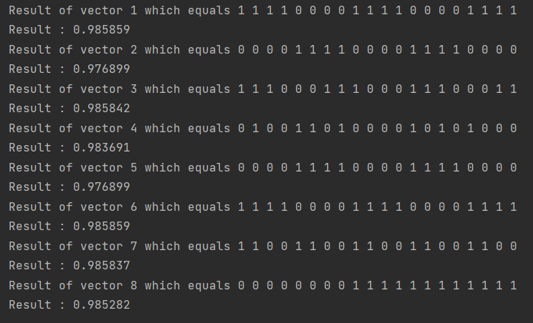

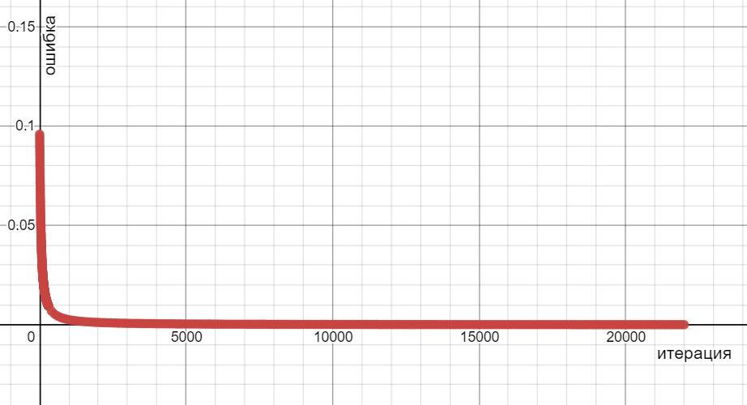

**Вывод:** я изучил обучение и функционирование нелинейной ИНС при решении задач распознавания образов.